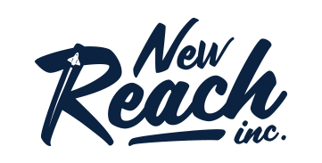

NEW REACH EDUCATION ANNOUNCES HIGHLY-ANTICIPATED INVESTING COURSE TO LINEUP
MultiVesting, a 7-week course, teaches new and experienced investors how to succeed in the stock market

PHOENIX (July 14, 2021) --- New Reach Education, a company offering educational courses in various industries, announced their latest stock and investing course set to launch on Monday, July 26th, called Multivesting.

Led by investment experts Chuck Fulkerson and Corey Lane, Multivesting teaches beginner, intermediate and advanced traders how to properly invest their hard-earned money in an ever-changing stock market. Due to current 2021 market trends and the rise of bitcoin and 3D options, trading is one of the hottest topics on social media platforms.

“In the stock market, investors are taught to focus solely on one investing strategy to the point that it’s perceived as the one and only strategy you need. We spent years with this mindset till we decided to flip the norm.” said Fulkerson, Co-Founder of Multivesting.

Fulkerson and Lane combine three different methodologies by looking at price charts and market trends. The course is designed to help students become confident traders in any kind of financial market.

The course also includes exclusive access to a private community of confident traders, and fellow students who are learning how to become confident traders, along with multiple live trading rooms each week. Students will learn how to build their portfolios, stay on top of trends and trade like real-time experts.

“There are thousands of courses out there, but what sets us apart is that we genuinely care. We put in the extra time to see our students succeed, no matter how long it takes. Our goal is to get our students to leave us because they don’t need us anymore,” said Corey Lane, Co-Founder of MultiVesting.

The course is available for people of all ages and backgrounds. To learn more about the course, visit multivesting.com

About New Reach Education
New Reach Education is a company based in Tempe Arizona focused on investment and financial education. They strive to flip the current online education space and optimize it for student success. Put simply, their goal is to change the world of education in order to make life better for the students. They believe that people who invest their money in education should come out as winners, not losers.

-- xxx --

For more information, please contact Luci Peterson, PR Manager at lucip@newreacheducation.com

